**relBCON** steps:

1. Copy the tar file to the Release Folder “UD/F.BCON.DATA/RELEASE”

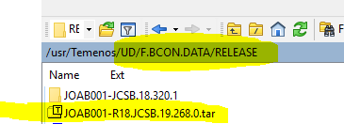

1. Call the command “**relBCON”** with the name of the tar file



1. Check that all components are released and authorized successfully, to exit use “++”, and if not successful on all records then relBCON again.

